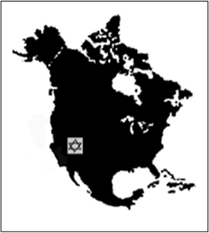
Western Jewish Studies Association
Founded: 1995
President: Lawrence Baron
Registration for 2019 Conference California State University, San Bernardino, Palm Desert Campus May 5-6, 2019
Name:
University Affiliation:
Address and email address:
Scheduling Preference:
Registration Fee (Checks Should Be Made Out to Western Jewish Studies Association):
______Conference Plus Lunch and Dinner $100
______Graduate Student, Conference Lunch and Dinner $50
______Community Auditor (no meals) $25
Dietary Preference:
____Chicken
____Fish
____Vegetarian
____Kosher
Send Completed Registration Form To: Lawrence Baron, 6072 Del Cerro Blvd., San Diego, CA 92120 by April 1, 2019.
Hotel Information: Fairfield Inn and Suites, Palm Desert, CA Phone: 760-636-1300 Start date: 5/4/19 End date: 5/6/19
Last day to book: 3/15/19 Fairfield Inn & Suites Palm Desert for 119.00 USD -129.00 per night. On-Line Booking Link:https://www.marriott.com/meeting-event-hotels/group-corporate-travel/groupCorp.mi?resLinkData=WesternJewish%20Studies%5ECTDPD%60WJSWJSA%7CWJSWJSB%60119.00-129.00%60USD%60false%604%605/4/19%605/6/19%603/15/19&app=resvlink&stop_mobi=yes

