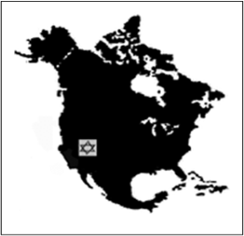

Western Jewish Studies Association
24th Annual Conference
May 5-6, 2019
California State University, San Bernardino Palm Desert Campus

Keynote Address: May 5, 2019
Child Survivors of the Holocaust in the United States Beth Cohen, California State University, Northridge
Plenary Roundtable:
Bringing Israel to Your Class, Bringing Your Class to Israel

Panels on:
Archeology and Architecture of the Jewish Past
Jews under British and French Colonial Rule
American Jewish Immigrant Experience
The Holocaust as History and Haunting Memory in Eastern Europe
Jewish Concepts, Practices, and Scripture
Modern Jewish Identities
The Jews in Russia and the Soviet Union
Jewish Intellectuals and the Transnational Experience
The Holocaust in Contemporary American Culture
The Shaping of Modern Israel
Gender, Marriage, and Childhood During and After the Holocaust
Jewish History in Southern California
American Perspectives on Hebrew, Israel, and Jews
Nazi Concentration and Death Camps
Legacies of the Wissenschaft des Judentums
Teaching Jewish Studies
American and Canadian Responses to Nazism and the Creation of Israel
Constructing Hybrid Jewish and non-Jewish Identities

For Registration and Hotel Information, see the WJSA website at:
http://www.wjsa.net/
lbaron@sdsu.edu

