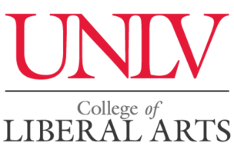

Call for Papers
25th Western Jewish Studies Association Conference
University of Nevada, Las Vegas
March 14-15, 2021

Call for paper and panel proposals on all areas of Jewish Studies regardless of discipline, geographical focus, or time period. The WJSA always devotes some panels to Jews in the American West, pedagogical aspects in Jewish Studies, and contemporary Jewish issues. Panels devoted to major Jewish anniversaries and birthdays in 2021 are also encouraged.
Paper proposals should be no longer than one double-spaced typed page and should be submitted with a short CV that contains contact information. Organizers of panels should submit a cover sheet with the title of the panel and the titles of each of the papers and contact information for presenters with their paper proposals and brief CVs. All interested scholars of Jewish Studies, including graduate students, are invited to submit proposals for papers and panels. A limited number of modest travel stipends are available for graduate students and overseas scholars presenting at the conference. Individuals wishing to chair a session should submit their CV.

Note: If you submitted a proposal for the 2020 conference that was accepted, indicate that on your submission email. You don’t have to send in the proposal again.

The WJSA confers the Baron Award for the best graduate student paper presented at the conference. The student will receive $200.

Although there is no WSJA membership requirement for participation in the conference, there is a higher registration fee charged for non-members. Deadline for submission of proposals is November 15, 2020.

Proposals and inquiries should be emailed to Lawrence Baron at lbaron@sdsu.edu

UNLV welcomes WJSA for the first time. We hope you will enjoy the campus and Las Vegas. UNLV is a doctoral-degree-granting institution comprised of approximately 31,000 students. The university is classified as an R1 research university and is ranked as the most diverse undergraduate campus in the nation by U.S. News and World Report. The UNLV College of Liberal Arts has just launched its Religious Studies Minor.

