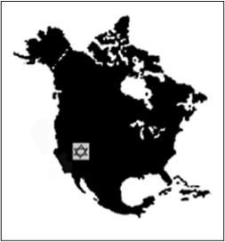
CALL FOR PAPERS
Western Jewish Studies Association Conference Schusterman Center for Judaic and Israel Studies
University of Oklahoma
March 27-28, 2022

Call for paper and panel proposals on all areas of Jewish Studies regardless of discipline, geographical focus, or time period. The WJSA usually includes panels about Jews in the American West, pedagogical aspects in Jewish Studies, and contemporary Jewish issues. It welcomes panels devoted to the major anniversaries of events in Jewish history or important Jewish individuals in 2022, for example:

1972: Ordination of First American Female Rabbi; Munich Olympic Games Massacre 1947: United Nations Partition Vote Creating Israel 1942: Wannsee Conference 1922 Death of Eliezer Ben Yehuda 1897 Founding Congress of the World Zionist Organization 1822 Publication of the first issue of Zeitschrift für die Wissenschaft des Judentums 1772: Birth of Nachman of Breslov 1572 Death of Isaac Luria
Paper proposals should be no longer than one double-spaced typed page and should be submitted with a short CV that contains contact information. The submission of panels on a common topic is encouraged. Organizers of panels should submit a cover sheet with the title of the panel and the titles of each of the papers and contact information for each presenter, followed by the individual paper proposals and brief CVs. Scholars of Jewish Studies including graduate students are invited to submit proposals for papers/presentations/workshops. A limited number of partial travel stipends are available for graduate students and overseas scholars who will be presenting papers. Individuals wishing to chair a session should submit their CV.

Although it is planning for a predominantly in-person conference, the WJSA will feature virtual panels. If you want to present virtually, you are encouraged to form a panel with other likeminded presenters. Individual virtual proposals will only be accepted if a thematically coherent virtual panel can be formed or if the COVID situation necessitates the holding of the conference virtually.

The WJSA annually awards the Baron Award to the best student paper presented at the conference. The winner receives $200.

Although there is no WSJA membership requirement for participation in the conference, a higher registration fee is charged for non-members.

Proposals should be emailed to Lawrence Baron at: lbaron@sdsu.edu The deadline for submission of proposals is November 15, 2021.

